Title:Fire Weather Index Predictor
(A Machine Learning model to predict Fire Weather)



Infosys Springboard Virtual Internship Program

Submitted By
T.Srikavya

Under the guidance of Mentor Praveen

Project Statement
This project focuses on building a Fire Weather Index (FWI) Predictor that estimates wildfire risk using essential environmental and fire-danger features such as temperature, relative humidity, wind speed, rainfall, FFMC, DMC, DC, ISI, and BUI. The dataset is thoroughly cleaned, pre-processed, and analysed to ensure reliable inputs, followed by visual exploration to understand feature distributions and relationships. Machine learning techniques are then applied to learn how weather conditions influence fire danger levels, enabling accurate prediction of the FWI value. The system also incorporates regional information to study area-wise fire behaviour and improve prediction relevance. Overall, the model aims to support early detection, risk assessment, and informed decision-making for effective wildfire management.

Expected Outcome
• A predictive ML model trained using Ridge Regression to forecast FWI.
• A pre-processing pipeline using StandardScaler for normalisation.
• A Flask-based web app where users can input environmental values and get FWI predictions.
• A system that can help forest departments, emergency planners, and climate researchers make data-driven decisions.

Modules to be Implemented
• Data Collection
• Data Exploration (EDA) and Data Preprocessing
• Feature Engineering and Scaling
• Model Training using Ridge Regression
• Evaluation and Optimisation
• Deployment via Flask App
• Presentation and Documentation

System Requirements
Software:
- Python
- Python libraries (pandas, numpy, matplotlib, seaborn etc)
- Flask

Milestone 1
- Module 1 (Data Collection)

The dataset was collected by exploring multiple online sources and selecting one that contained the essential environmental features required for FWI prediction, including Temperature, Relative Humidity, Wind Speed, Rain, FFMC, DMC, ISI, and Region. After loading the chosen dataset into a Pandas DataFrame, an initial inspection was carried out to understand its structure and quality. This included checking datatypes, identifying null values, reviewing memory usage, and generating statistical summaries to examine the distribution and range of numerical features. The dataset’s shape and duplicate entries were also analysed to ensure completeness and reliability, providing a solid foundation for further preprocessing and modelling.

Conducted initial inspection to understand feature distributions and data quality.

- Load the dataset
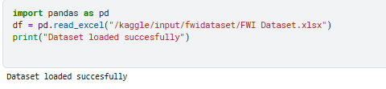

- Verify Datatypes

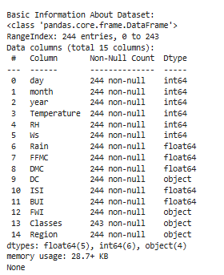

- Basic Information of the Dataset

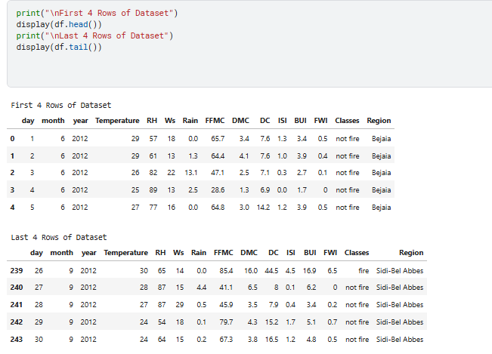
FIG 1: Information of Dataset

The first and last four rows of the dataset were displayed to gain an initial understanding of the data structure, feature values, and overall formatting. This helped verify that all columns loaded correctly, values are aligned, and the dataset is ready for further inspection and preprocessing.

- Statistical Summary
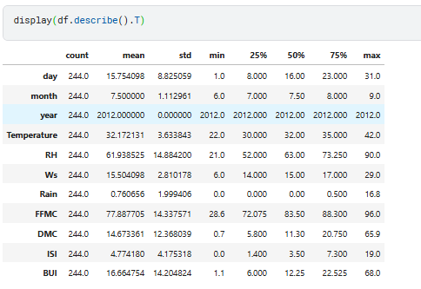
FIG 2: Statistical summary of the Dataset

A statistical summary was generated to examine key numerical characteristics such as mean, median, minimum, maximum, and standard deviation for each feature. This helped assess data variability, detect potential outliers, and understand the overall distribution of numerical values in the dataset.

- Duplicate Values
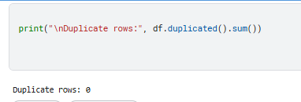

- Module 2 (Data Exploration (EDA) and Data Preprocessing)

During the preprocessing stage, the dataset was first examined for missing or null values, and appropriate handling techniques were applied to ensure completeness. Outlier detection was then performed using boxplots and statistical thresholds to identify abnormal values that could affect model performance. To better understand feature behaviour, data distributions were visualised through histograms and density plots, while correlation matrices and scatterplots were used to explore relationships between variables. Categorical features, such as Region, were encoded using label encoding to make them suitable for machine learning algorithms. Finally, the cleaned and processed dataset was saved for use in building and evaluating predictive models.

- Handle missing values
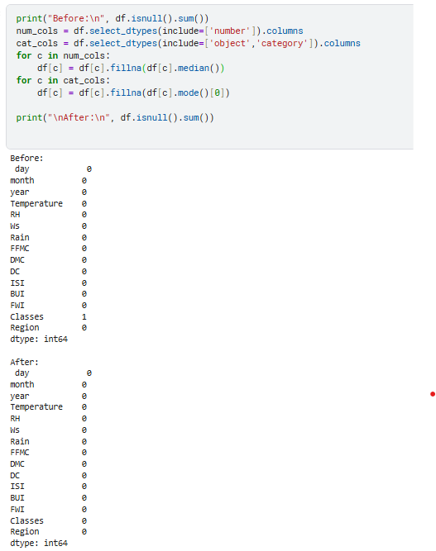
FIG 3: Before and After Missing Values

A missing-value check was performed to identify incomplete records, revealing that only one row contained a null value in the Classes column. This validation helped ensure data completeness and supported appropriate handling before further preprocessing.

- Boxplot and statistical threshold using the IQR method
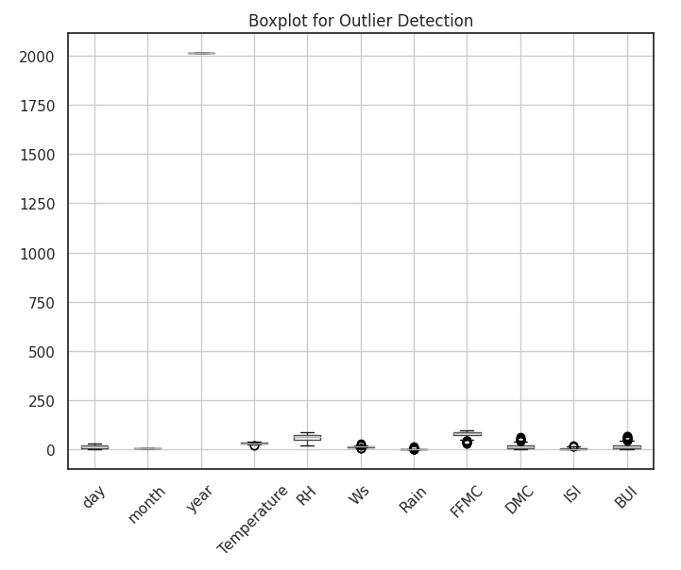
FIG 4: Outlier Detection
Outlier detection was performed using both boxplots and the Interquartile Range (IQR) statistical method to identify unusually high or low values across numerical features. The IQR approach calculated lower and upper bounds for each feature, flagging values that fell outside the 1.5 × IQR range as potential outliers. While some features like day, month, year, RH, and DC showed no outliers, others such as Temperature, Wind Speed, Rain, FFMC, DMC, ISI, and BUI contained multiple extreme values. These findings helped reveal variability patterns within the dataset and informed decisions for further cleaning and preprocessing.

- Density Plots and histogram for each feature

Histograms with KDE density curves were generated for all numerical features to visualize their distributions and identify underlying patterns. These plots helped reveal whether features were normally distributed, skewed, or contained extreme values. Variables like Temperature, RH, and Wind Speed showed smoother, more symmetric distributions, while features such as Rain, DMC, ISI, and BUI displayed strong right-skewness. This visual exploration provided valuable insights for understanding variability and preparing the data for modeling.
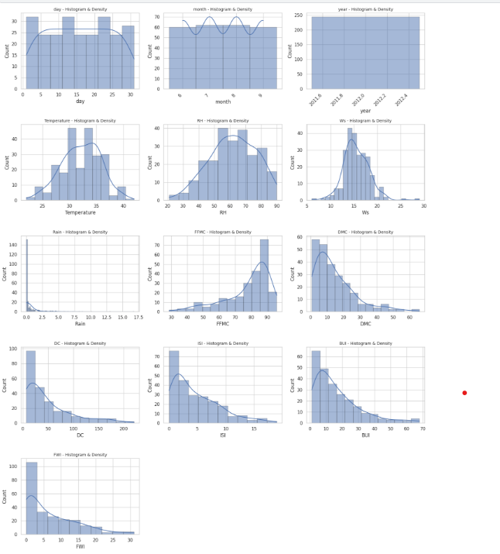
FIG 4: Histogram with KDE curves for features

- Compute the correlation matrix for numerical features

A correlation matrix was generated to explore relationships among numerical features and identify which variables influence each other most strongly. The heatmap revealed that fire danger indices such as BUI, DMC, FFMC, and ISI have high positive correlations with each other and with Temperature, indicating shared patterns in fire behavior. Relative Humidity showed strong negative correlations with several indices, reflecting its inverse effect on fire risk. These insights helped highlight key predictive features for the Fire Weather Index and guided feature selection for modeling.

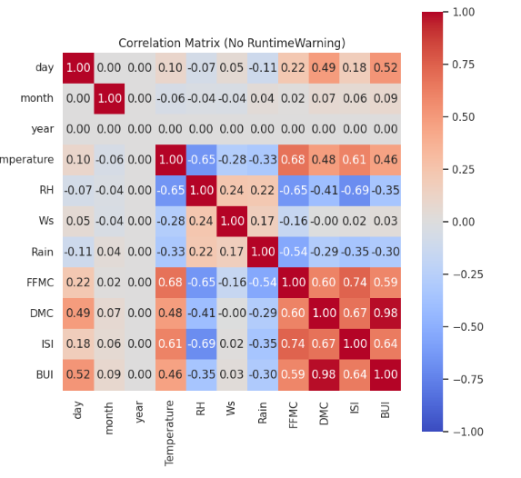
FIG 5: Correlation matrix

- Scatter plots for Features vs FWI
Scatter plots were used to visualize the relationship between each numerical feature and the Fire Weather Index (FWI). These plots helped identify how strongly each variable contributes to fire risk.
Key observations:
- FFMC, DMC, and ISI show clear positive upward trends, meaning higher values of these indices are strongly associated with higher FWI. These features are likely strong predictors in the model.
- Temperature also shows a moderate increasing trend with FWI.
- Rain and RH show negative or weak relationships, as higher rainfall and humidity typically reduce fire danger.
- Wind Speed (Ws) shows a more scattered pattern, indicating a weaker or less direct relationship with FWI.
.
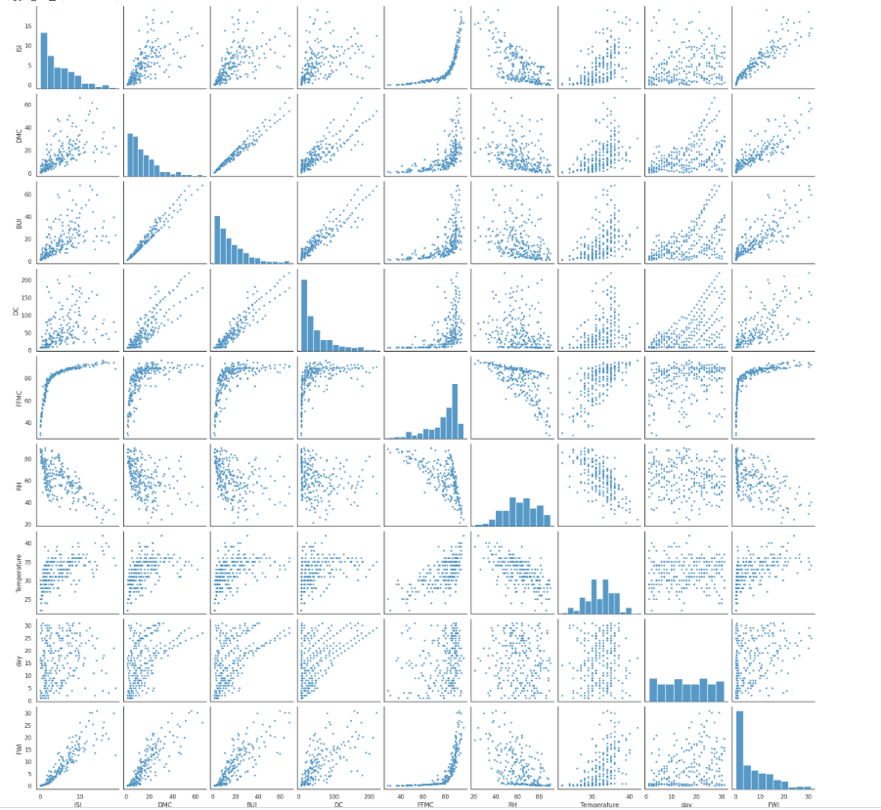
FIG 6: Scatterplot for features and FWI
- Encoding region
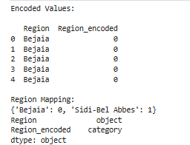
The Region column was label-encoded to convert the categorical values into numerical form. 'Bejaia' was encoded as 0 and 'Sidi-Bel Abbes' as 1. The new column Region_encoded was added and stored as a categorical type, preparing the feature for machine learning algorithms.
- Saved the cleaned dataset for use in modeling

